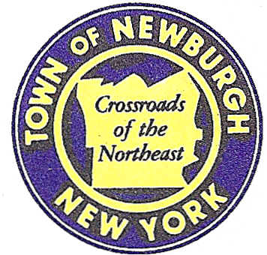

TOWN OF NEWBURGH
_______Crossroads of the Northeast __________________________
OLD TOWN HALL
308 GARDNERTOWN ROAD NEWBURGH, NEW YORK 12550

PLANNING BOARD
JOHN P. EWASUTYN, CHAIRMAN
TELEPHONE 845-564-7804
FAX 845-564-7802
E-MAIL: planningboard@townofnewburgh.org

PLANNING BOARD AGENDA

May 18th, 2017

*PLEASE NOTE: The Planning Board Meeting will start at 7:00 P.M. and all Applicants/Representatives
are to be present at that time. The Meeting will be held in the Meeting Room of Town Hall,
located at 1496 Route 300, Newburgh NY.*

1. Pet Hotel and Day Care Facility (12-19) SITE PLAN
West side of Rt. 9W, north of Lattintown Road
Section 9, Block 3, Lot 22.22
Zone: B
Rep: TM DePuy Engineering and Land Surveying, PC
2656 Route 302
Middletown, New York 10941

2. Carlos Dominques II Subdivision (15-29) 6 LOT SUBDIVISION

Section 7, Block 1, Lot 1.5
Zone: A-R
Rep: Talcott Engineering Design PLLC
1 Gardnertown Road
Newburgh, N.Y. 12550

3. Hudson Asset Subdivision (17-04) 5 LOT SUBDIVISION
Union Avenue
Section 34, Block 1, Lot 25.1
Zone: R-2
Rep: Talcott Engineering Design, PLLC
1 Gardnertown Road
Newburgh, NY 12550

*WORK SESSION*
Project Readiness Discussion scheduled for 5:30 p.m. in the Meeting Room of
Town Hall on Thursday, May 18th, 2017.*

4. Fabrizio Two Lot Subdivision (17-05) PUBLIC HEARING
Gardnertown Road TWO LOT SUBDIVISION
Section 51, Block 9, Lot 9
Zone: R-1
Rep: Talcott Engineering Design, PLLC
1 Gardnertown Road
Newburgh, NY 12550

5. US Crane & Rigging (16-14) CONTINUATION OF PUBLIC HEARING
18 Route 17K
Section 97, Block1, Lot 21.2
Zone: IB
Rep: Maser Consulting, P.C.
555 Hudson Valley Avenue, Suite 101
Newburgh, NY 12550

PLANNING BOARD BUSINESS
WORK SESSION

1. Patton Ridge (2012-18) 6 month extension request from May 18, 2017 through November
18, 2017.

*WORK SESSION*
Project Readiness Discussion scheduled for 5:30 p.m. in the Meeting Room of
Town Hall on Thursday, May 18th, 2017.*

